**Abstract**

In this study, we present how we can employ BART, T5 and PEGASUS trained on the conversational text summarisation dataset called SAMSum. The goal is to measure how well the proposed models maintain coverage and coherency in summaries of dialogue information. Leveraging Google Colab with GPU support, we implemented a systematic training and evaluation process, measuring performance with ROUGE scores across four metrics: These evaluating metrics include ROUGE-1, ROUGE-2, ROUGE-L, and ROUGE-Lsummary.From the result comparision,it observed that BART average ROUGE score of 0.009523, T5 average ROUGE score of 0.025985 and PEGASUS average ROUGE score of 0.011731. The outcomes reveal that T5 yielded the best ROUGE scores, which evidences its ability to learn highly relevant dialogue information more effectively and concisely than the competing models, including PEGASUS and BART. At the same time, some issues arise when it comes to improving the level of summarisation and its precision for the informal and dissimilar conversation structure. This study demonstrates that transformer models may improve solutions in industries that involve dialogue summarisation, therefore extending her work to industries like customer service, content moderation, and conversational analytics.

**Introduction**

In the modern world, we can obtain a relatively large quality of information with just a hint of changes on our devices. New ways of comprehending and handling all of this data are needed. A text summary is helpful because it organizes information with attention to detail. It broke vast chunks of text into short, digestible chunks in the form of notes and preserved crucial facts. The summarized text is even more vital. It concerns the growing problem of information abundance resulting from the need for high speed and effectiveness in searching for information. Additionally, it saves time and effort in information processing. Text summarizing helps improve productivity.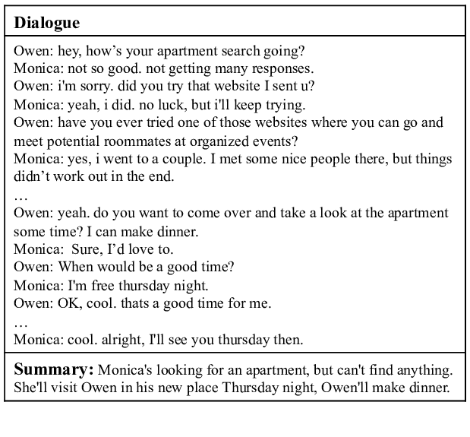

Summarisation generates a small-scale but meaningful text from more extended text, keeping the most helpful information intact. I am leaning on recent developments in deep learning neural networks, namely, sequence-to-sequence models, regardless of the existence of the attention mechanism.

These deep learning models, especially the ones based on Transformer topologies, are among the state-of-the-art text summarisation tasks. Therein, they surpass traditional approaches in synthesizing summaries that are smooth, cohesive, and meaningful to context. Nevertheless, challenges persist, mainly when concerned with identifying meaning in a particular area of focus or significant texts when a reader is expected to be knowledgeable of the content of the text.When the same models are applied to other domains including news summarisation, legal document summary and scientific article summarisation, the strengths and weaknesses of the current methodologies have been established.

**Methodology**

As the primary dataset for this research on dialogue summarisation, the SAMSum has been selected because it portrays real-world dialogues with human-summarized sums. It is officially acknowledged in the NLP field as the dataset for dialogue summarisation tasks that enable extractive as well as abstractive methods. This work provides an explanation of the internal and external composition of the SAMSum dataset, the information the database contains and how it benefits users before giving an account of the rationale for choosing the dataset.

The next step is data preprocessing when dialogue data will be prepared in its original form for application to machine learning models after choosing the SAMSum dataset. This action leads to improved quality of data, and managing of noise levels while organizing data structures that will allow models to make their learning. Considering the nature of the SAMSum dialogues, preprocessing is a crucial pre-step for handling such issues as slang, non-full sentences, and asymmetric conversation structure.

Here in this research, tokenization was performed using a pretrained BART tokenizer Facebook/BART-Large-CNN from Hugging face Transformers. The BART approach, especially suited for the summarisation task, implies that both input and target sequences are tokenized to facilitate sequence learning at the sequence level. This section defines how the input text known as “dialogue” has been tokenized, along with the same fate for the goal text described as “summary.”

To obtain excellent text summarisation for the Samsung dataset, we tested three sophisticated deep learning models: These models include BART, PEGASUS and T5 all of which are architectures of the Transformer. Composed of both encoder-decoder architecture and autoregressive decoder, BART also learns context understanding from its denoising pretraining objective. PEGASUS used for abstractive summarisation has a recent unique pretraining approach of masking out entire phrases so it focuses on important contextual details that are ideal for denser technical tables such as; Samsung’s. T5 now known as Text-To-Text Transfer Transformer is a general purpose network that looks at all NLP tasks as text generation problems.After the training procedure, the parameter of the self constructed SAMSum model was evaluated using the validation and test set. For evaluation, ROUGE a simple tool was applied with the scores from ROUGE-1, ROUGE-2, and ROUGE-L F1 as a way of measuring how well a model can identify the more important issues being discussed.

**Results and Discussion**

we compared the performance of three models fine-tuned on the SAMSum dataset for text summarisation: Pegasus, T5, and BART. Using ROUGE (Recall-Oriented Understudy for Gisting Evaluation) metric, the output of each model was assessed, primarily giving importance to ROUGE-1, ROUGE-2, and ROUGE-L ROUGELSUM measure that estimate the extent of unigrams, bi-gram, and longest common subsequence respectively between the generated and reference summaries.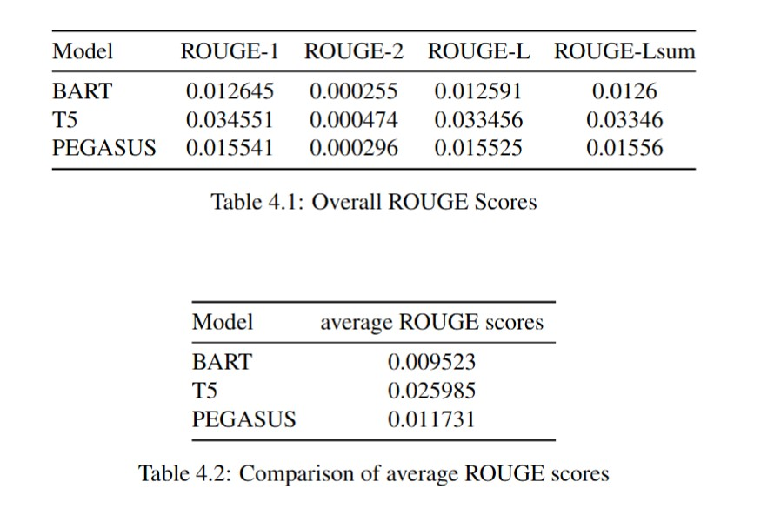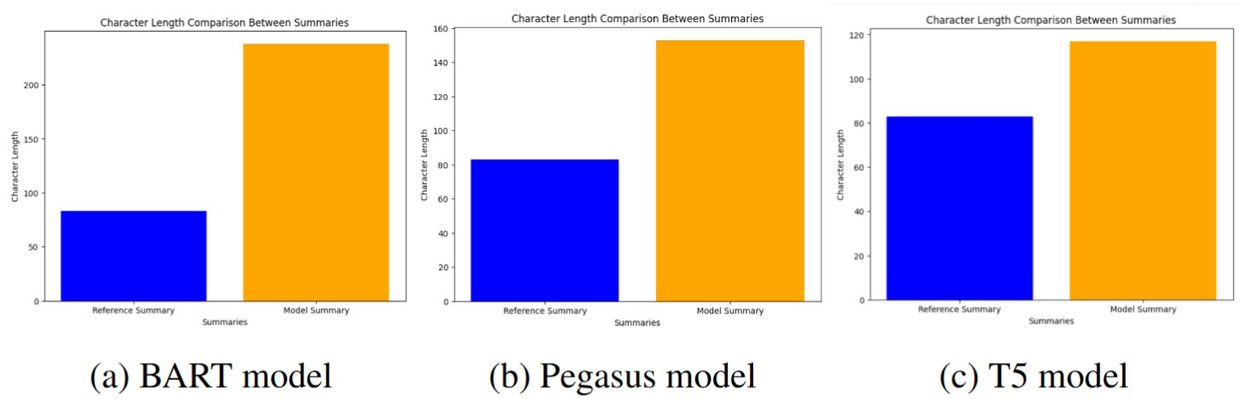

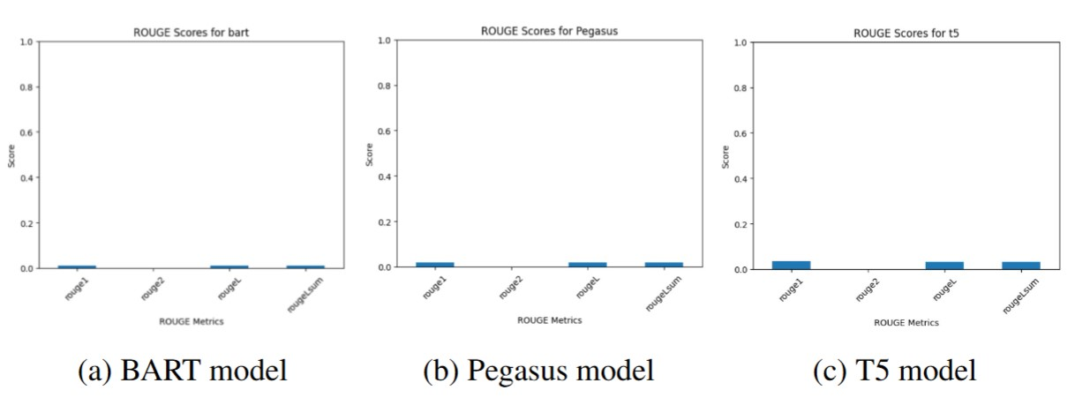

**Conclusion**

In this work shows that transformer-based models such as BART, T5, and PEGASUS are promising for conversational text summarisation, mainly when applied to the SAMSum dataset. Conducting systematic training and testing of T5 in a GPU environment showed that T5 yielded the highest ROUGE scores, indicating its better capability to generate and recapitulate dialogue content. Even though the performance of PEGASUS and BART was rather similar, owing to the architecture of T5 and the obtained pre-trained weights, the summaries were less ambiguous and provided more comprehensive information.

**References**

1. Hugging Face. *Samsum Dataset.* HuggingFace, <https://huggingface.co/datasets/samsum>.
2. S. Chopra and et al., “Title of the paper by chopra et al.,” Journal Name, vol. X,

no. Y, Z–W, 2016.

1. A. M. Rush and et al., “Title of the paper by rush et al.,” in Proceedings of the

Conference Name, 2015, A–B.

1. U. Khandelwal and et al., “Title of the paper by khandelwal et al.,” in Proceed-

ings of the Conference Name, 2019, pp. C–D.

1. T. F. N. Zhang and et al., “Title of the paper by zhang et al.,” in Proceedings of

the Conference Name, 2019, E–F.